**Weather and Events App**

This was our first wireframe for a very basic version of what our app would look like 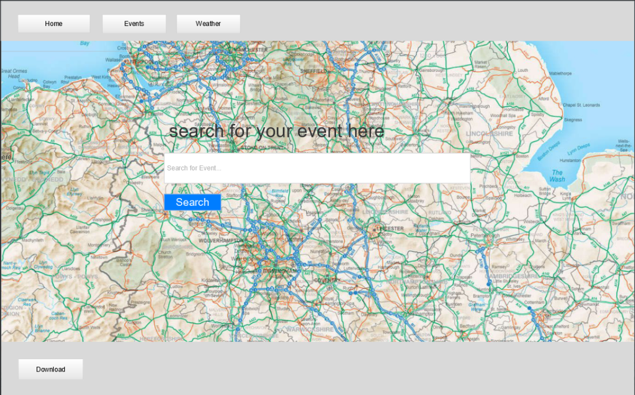

.

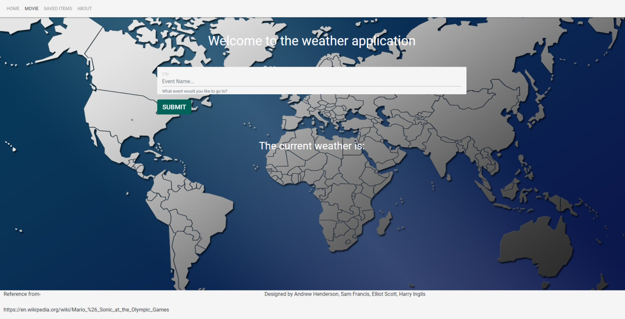This was then our second idea

The two API’s we have chosen are [OpenWeatherMap](https://openweathermap.org/api) and TicketMaster. The idea behind our website is that you will search up an event you are looking for and the event will be fetched and the weather forecast for that day will be displayed.

There is a link to TicketMaster in our navigation bar, which will allow users to browse for events. When they have found an event they are interested in, they can put this into the search bar of the Weather and Events page and they will be shown what the predicted weather will be for that given day.

This is a useful application because it will allow people to prepare for the event they are going to appropriately. For example, if it is raining and you are at a concert outside, you can prepare accordingly by bringing your own coat, meaning you do not have to overpay for a poor-quality rain covers that are often provided at festivals.

Equally, if it is going to be nice weather you will know not to layer up, saving the hassle of having to look after a jumper or coat, and running the risk of losing it.